Contacting Kent Police

Please remember in an emergency always dial 999

For any non-emergency enquiries please visit the Kent Police website where you can:
- Submit an online report of a crime or other incident
- Use our “Live Chat” function
- Contact Crime Stoppers
- Follow links to our Social Media platforms including Twitter and Facebook
- Find information about Crime Prevention and our Partners
- Call 101
Community engagement  - 08/09/26 – 14:00 - 16:00 Deal Leisure centre, Ct149UU  - 25/09/26 – 09:00 - 11:00 Deal Leisure centre, Ct149UU  - 20/10/26 – 14:00 – 16:00 Deal Leisure centre, Ct149UU  - 11/11/2026 – 16:00- 18:00 Deal Leisure centre, Ct149UU | Your local Neighbourhood Police Officer  PC 14596 Kyle Waymark

What is StreetSafe?

As part of the government’s agenda to tackle violence against women and girls, we are using a new online tool called StreetSafe to enable people, particularly women and girls, to report locations where they feel or have felt unsafe and to identify the features on why that location made them feel unsafe.

The focus of this is to identify particular areas and factors that lead to people feeling unsafe and might help offenders either commit or conceal a crime – such as street lighting, abandoned buildings or poorly designed spaces, vandalism, as well as behaviours of individuals or groups of people.

StreetSafe is anonymous StreetSafe | Police.uk (www.police.uk)



Suspect charged as vehicle crime crackdown continues in Deal

A suspect has been promptly charged by Dover officers as the clampdown on vehicle crime across the district continues.
Between Wednesday 15 and Sunday 19 July 226, Kent Police received reports that vehicles had been tampered with in Diana Gardens, Mongeham Road and Glack Road, Deal. Enquiries were completed by officers and an arrest was made on Tuesday 21 July.
Charges secured
The following day, vehicle interference charges were secured against Mitchell Gent, 28, of Freemens Way, Deal.
Mr Gent appeared before Folkestone magistrates and was bailed with conditions to a hearing at Canterbury Crown Court on Friday 14 August.
Enforcement tactics
Measures being taken in response to reports of vehicle crime in Dover district have included increased, high-visibility patrols in target areas and proactive vehicle stops.
Dover District Commander, Chief Inspector Liz Cokayne-Delves, said:
‘We understand the concern and frustration that vehicle crime causes for victims and the wider community. We want residents across Dover district to be reassured that we are committed to tackling this issue, and my officers are using a range of enforcement tactics.‘I would also urge anyone who witnesses suspicious activity, or has information about offending, to report it to us promptly. My officers will always pursue the most robust options available to them, including prosecution where appropriate.’
Suspect charged as vehicle crime crackdown continues in Dover | Kent Police

Further help and safety advice - https://www.kent.police.uk/cp/crime-prevention/

Deal Carnival week -
Good morning all residents of Deal,
As one of the two dedicated Beat Officers for Deal, I continue to focus on supporting residents in my wards of Mill Hill and Middle Deal, while also assisting colleagues across the wider district when operational demands require it. Of late I have been assisting various colleagues over the larger Dover district, with arrests or enquiries to locate missing people but strive to return back to Deal wherever possible.
Between 29 July and 1 August, Deal welcomed thousands of visitors for Carnival Week. While the event was a great success, it also led to an increase in reports of anti-social behaviour and alcohol-related incidents in some areas.
Kent Police worked closely with event organisers and partner agencies to ensure a visible policing presence throughout the festivities. With dispersal powers in place along much of the seafront under Sections 34 and 35 of the Anti-social Behaviour, Crime and Policing Act 2014, officers were able to deal proactively with individuals whose behaviour was negatively affecting others.
Over the course of the events, officers issued numerous dispersals and took positive action where necessary. In total, six individuals were arrested and removed from the event area, helping to prevent further disorder and allowing the vast majority of attendees to continue enjoying the celebrations safely.
While enforcement action is sometimes necessary, our priority remains ensuring that residents and visitors can enjoy local events in a safe and welcoming environment.

Due to the Surveys that are broadcasted on My Community Voice your priorities are generated to assist us in working out what matters to you.

I will be out enforcing and actioning anything relating to these as a priority.

- Road Safety Issues
I will be out in the ward, in suitable or hotspot location carrying out enforcement. Enforcement comes in many ways but could come as random spot checks, speed checks, and enforcement of the road traffic act for matters such as phones, seatbelts and insurances.

- Drug dealing and Drug use
I and other police are out and about within the Middle deal ward and others eitherin police uniform and undercover trying to sort this issue. The war on drugs is an endless battle, howevr still being fought. I am oftern in this ward weaing plain clohtes and using effective stop search powers to ensure drugs are conviscated and prosecutions sought. Further to this plans will be made to ensure concentrated targeting takes place.

- Drink / Drug driving
Drink/ drug driving is a leading cause of accidents on the road. Due to this I and others work very close with licenced premisis and are cracking down on the first time and repeat offenders. If they are caught, they will be prosecuted and disqualifed from driving further.

As always, every 3 months good results on these priorities will be published on Kent police website under ‘your area’ and highlighted on these newsletters
www.kent.police.uk/yourarea

If you know anything that can help me help you – Please get in touch.


Useful contacts for advice about fraud and cyber crime
If you’d prefer not to speak to the police or would like more specific advice, the charities, groups and organisations below can also provide information and support.
Action Fraud
Members for the public - 0300 123 2040 (Monday to Friday, 8am to 8pm)
Businesses, charity or other organisations suffering a live cyber-attack - 0300 123 2040 (Available 24/7)
Action on Elder Abuse (AEA)
AEA are a national charity working to protect and prevent the abuse of vulnerable older adults.
0808 808 8141
Age UK
Provides companionship, advice and support for millions of older adults. 0800 169 6565

The Silver Line
Free, 24-hour, confidential helpline providing friendship, information and advice to older people.
0800 4 70 80 90

Office of the Public Guardian (OPG)
The OPG is responsible for protecting people who no longer have the capacity to make certain decisions for themselves.
0300 456 0300
Citizens Advice
Free, independent and confidential advice to help you solve legal, money and other problems.
0808 223 1133
Cyber Aware
Cyber Aware provides cyber security advice for small business and individuals.
Get Safe Online
Get Safe Online is the UK’s most popular source of easy-to-understand information about online safety.

Information Commissioners Office
The role of the Information Commissioners Office is to uphold information rights in the public interest. This includes guidance on home CCTV systems Home CCTV systems | ICO

Online Dating Association (ODA)
Dating services with ODA membership abide by a strict code of standards or risk having their membership rescinded.
Royal Mail Scam Mail Helpline
Support and advice if you’ve received items by post that you believe to be fraudulent.
0800 011 3466
The Mailing Preference Service (MPS)
A free service supported by Royal Mail enabling UK customers to remove their name and home address from mailing lists used by the industry.
020 7291 3300
The Telephone Preference Service (TPS)
Free service for recording your preference not to receive unsolicited sales or marketing calls.
0800 398 893

How the police can help you
In an emergency always call 999. In a non-emergency you can call the police on 101.
If you can’t speak out loud, you can press 55 so that the operator knows you need help.
If you need to, the option to video call is available to communicate in BSL. This option is free. Simply visit the 999 BSL website or download the app.

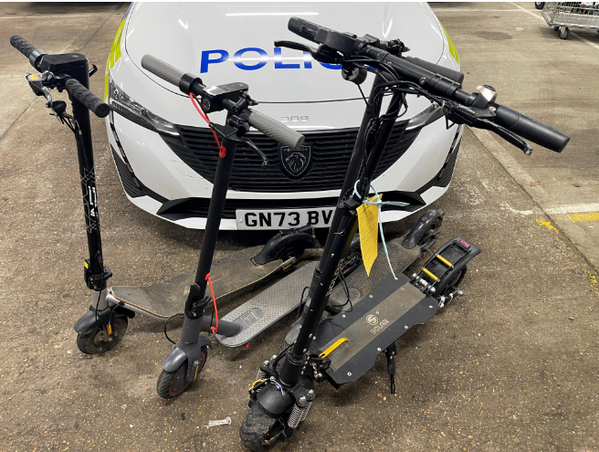

Electric Scooters – know the law

If seen in Deal on an E-scooter – expect to be stopped, and the article seized and potentially prosecuted with 6 points on a driving licence and a £100-300 fine.

Although e-scooters can be great fun, it’s against the law to ride one on a public road, cycle lane or pavement. Please share this information with friends and family.

E-scooters are classed as Personal Light Electric Vehicles (PLEVs), which means they are treated as motor vehicles and subject to the same legal requirements, such as driving licence, insurance, number plates, lighting, road tax, crash helmets etc. Without these, e-scooters cannot be used legally on the road.

The Government is currently trialling the use of approved rental e-scooters as environmentally friendly modes of transport in some specific locations in the UK.

For the rest of the country, under current law, e-scooters can only be used on private land with the landowner’s permission.

We are obliged to take action against anyone who is caught repeatedly using an e-scooter illegally or in a way that causes a nuisance to others. In these circumstances we have the power to seize the e-scooter under Section 59 of the Police Reform Act/165 of the Road Traffic Act – and we’d really prefer not to.

For more information about powered transporters and the law, visit www.gov.uk

