An Update from August…
Safer Neighbourhoods

September 2026
Matlock & Tansley.

What has the team been up to?

Warrant executed:
Earlier this month, the Matlock SNT, together with the teams from Bakewell, Ashbourne and Dog Section, conducted a raid on a property in Ashbourne suspected of growing cannabis plants in their premises. The teams conducted an early AM raid on the property and were able to seize several cannabis plants from the address.

Hotspot patrols:
As per the quarterly priorities, your local SNT have increased foot patrols throughout hotspot areas, such as Hall Leys Park, during the School summer holidays. This increased visible presence in these areas has had a noticeable knock on affect and seen a reduction of ASB offences on the Park.

No insurance, no Horsebox:
A first for the Matlock team this month. Whilst on mobile patrol, two of your local SNT officers spotted a large horsebox entering a petrol station through the exit point. This peaked Officer curiosity and quickly paid off when Officers checked and saw that the vehicle was being driven with a cardboard registration plate. After some checks, the registration plate that they had drawn on didn’t come back to the vehicle it was attached to. Officers seized the vehicle for being driven with no insurance.

Street meet dates
Hall Leys Park, Matlock- 5th of September 1400-1500

Highfields lower, Matlock- 7th of September 1500-1600

Imperial Rooms, Matlock- 11th of September 1100-1200

Imperial Rooms, Matlock- 18th of September 1100-1200

Soul Food café, Matlock - 16th of September 1100-1200

Market day, Hall Leys Park, Matlock- 23rd September 1300-1400

All Saints Primary School, Matlock- 24th of September 1500-1530

Milk Churn, Hurst Farm, Matlock- 29th of September 1100-1130

Safer Neighbourhoods
Matlock & Tansley.

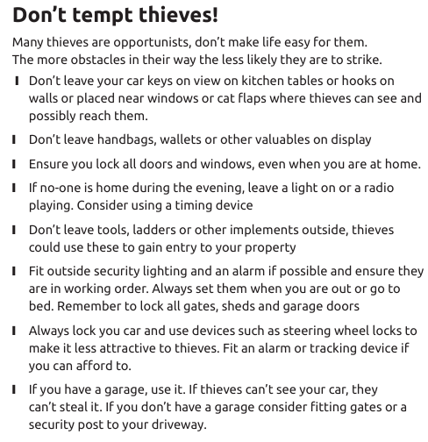
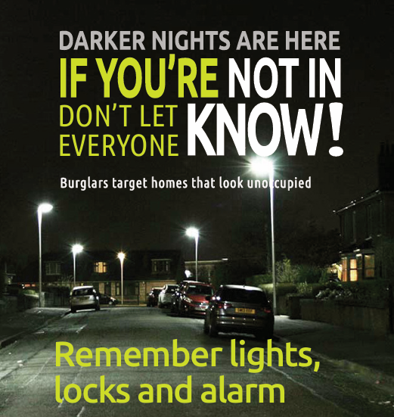
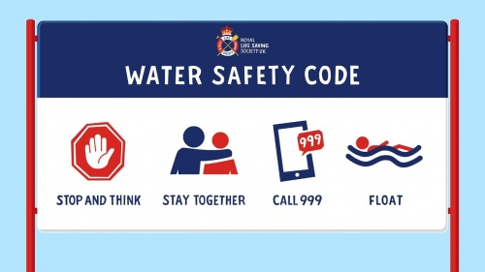
Bike Safe Workshops
BikeSafe isn’t a formal training programme, but a workshop built by bikers, delivered by bikers, for bikers.
It’s a police-led initiative where advanced police bikers share their extensive skills and experience, to help you get more out of your riding.
You’ll first learn the theory behind advanced riding, such as reading the road, cornering, positioning, braking, hazard perception and rider attitude. Once you’ve grasped this, you’ll then put it to the test during an observed ride with a police biker following you, stopping regularly to give you practical advice on how to enhance these skills. Afterwards, they’ll give you feedback on how to take this further, with pointers on what you can do to become an even safer and more confident rider. For more information on BikeSafe, and how to book a slot, simply search “BikeSafe” into your browser to see available slots.

