

We have listened to you.

Issue:
Aug 26

Western Ward

Newsletter

Introduction

#YouSaid
-

What matters to you

PS Simon WALTERS

PC Dave MARTIN

PC Callum JOHNSTON

PC Georgia POWELL

PC Lee FLAVILL

PC Alex ALDRICH

PCSO Pete SMITH

PCSO Sally
-
Ann MORGAN

PCSO Sabra BABAI

PCSO Andy BROWN
PCSO Grant JARVIS
Priority 1
Dangerous and illegal use of vehicles around the Western Ward continue to be reported and raised as concerns by local residents. Speeding, E-bikes and E-Scooters and dangerous parking outside Primary Schools have all been highlighted.
Action
The whole team have been working hard with high visual patrols by the PCSOs & PC, also some plain clothes work by officer in which the followed and recovered two Surron illegal bikes from an address in cuffing close. Also, our safer streets team have been doing some good work with Opp peddle-fast
Priority 2
Retail crime continues to be a problem for our shops across the Western ward which is causing staff to feel unsafe whilst at work.
Actions
Officer have been doing regular plain clothes patrols outside local stores and targeting those people who cause the shops and shoppers most harm, All stores on the beat and some close by are in a what-app group and pass information to other stores so they can be vigil to persons committing crime in the area.
Priority 3
The community in the area of Styon Road, Keightley Road and Lamen Road tell us that youths are regularly causing Anti-Social Behaviour in and around the grassed Play area. Motorcycle gatherings causing excessive noise, Vandalism/damage to Property are regularly being reported.
Actions
Luke Westell council ASB officer will be issuing warning letters to address on Styon Road & Holmwood Drive these two addresses have causing issues for local residents and a joint approach both by Police and council will hopefully address the issue or stronger action will be taken, again Plain clothes and high visual patrols will be completed.

Dear Reader,
I am writing to provide an update on some significant positive outcomes achieved by local officers as part of our continued efforts to tackle serious violence, criminality, and anti-social behaviour affecting our communities.
Over recent weeks, officers have been targeting a group of individuals responsible for causing considerable harm and concern within local neighbourhoods. Through dedicated investigative work, proactive enforcement activity, and support from partner agencies, a number of key individuals have now been brought to justice.
The following outcomes were secured:
- Juderoy DAVIS and Jacob GREEN were arrested, charged, and remanded to court for Grievous Bodily Harm with Intent.
- Shaun ASTILL and Kaiser ASTILL have both been arrested, charged, and remanded to court for Grievous Bodily Harm with Intent. They have pleaded guilty to this offence.
- A male was arrested in connection with two thefts of motor vehicles. He was also charged and remanded to court for breaching a Civil Order.
- A male was arrested and remanded to court for breaching an EMS Tag requirement.
Alongside these arrests and charges, officers have identified and evidenced more than ten breaches of Civil Injunctions involving three principal members of the group. This demonstrates our determination to use every available legal power to disrupt those who seek to cause harm in our communities.
Operational activity has also led to the recovery of a number of motorcycles believed to be linked to criminality and anti-social behaviour. These seizures not only remove vehicles being used unlawfully but also contribute to improving safety and reducing nuisance for residents.
Detective Inspector Paul Hawkins, City CID, said:
"These positive outcomes are the result of a significant amount of investigative work and the close collaboration between City CID, neighbourhood policing teams and wider departments. My team has worked extensively to support these investigations, gathering evidence and ensuring offenders are brought before the courts wherever possible. This has been a genuine team effort, with officers and staff from across the force working together towards a common goal of protecting our communities and reducing the harm caused by those involved in serious criminality."
While these results represent a significant step forward, our work continues. We have further plans in place to target prolific offenders and those who persist in committing crime across West Leicester. Our message is clear: we will continue to pursue those who cause harm, hold offenders accountable, and work tirelessly to keep our neighbourhoods safe.
I would like to thank our communities for the information, intelligence, and support that have assisted these investigations. The information you provide remains invaluable and plays a vital role in helping us identify offenders, protect victims, and prevent further crime.
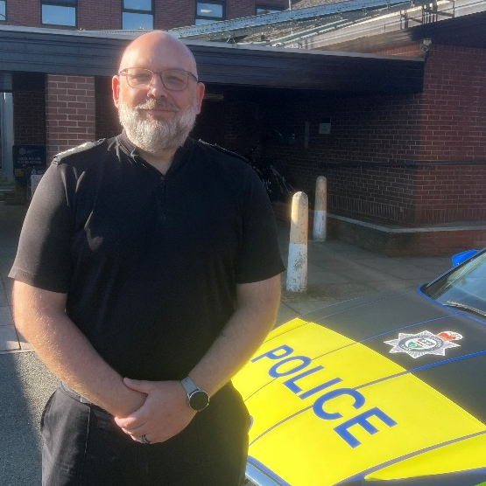
West Leicester Neighbourhood Policing Area remains committed to tackling violence, anti-social behaviour, and organised criminality. We will continue to listen to community concerns, act on intelligence, and ensure that those responsible for criminal activity are brought to justice.
Thank you for your continued support.
Yours sincerely,

Inspector 786 Ryan Hayes
West Leicester’s Neighbourhood Policing
Area Commander

Commander
West Leicester Neighbourhood Policing Area
Leicestershire Police

Anti-social behaviour survey |  | Your Views Survey

Upcoming beat event Activities eat

Girls empowerment
4:00PM - 7:00PM, Wed 16 September 2026
Team HUB St Oswalds Road

Beat Surgery New Parks Library
6:00PM - 7:00PM, Wed 16 September 2026
New Parks Library, 321 Aikman Avenue

Beat Surgery at One Stop Shop on Stephenson Drive
11:00AM - 12:00PM, Tue 22 September 2026
One Stop Shop, 155 Stephenson Drive, Leicester

Beat surgery
10:00AM - 12:00PM, Fri 25 September 2026
St Annes community hall Letchworth Road

NHW crime prevention
9:30AM - 12:00PM, Sat 26 September 2026
St Annes Community church hall Letchworth Road

Community Events

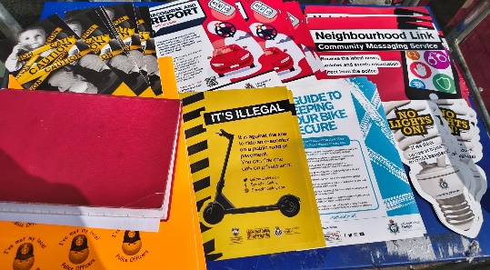
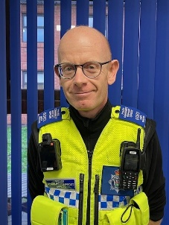


Beat surgery events have been popping up all over the beat by all the PCSOs and PC please come along and express your concerns for your community

#NeighbourhoodPolicing #SaferStreets #WesternWard
Follow us @LPWestLeicester

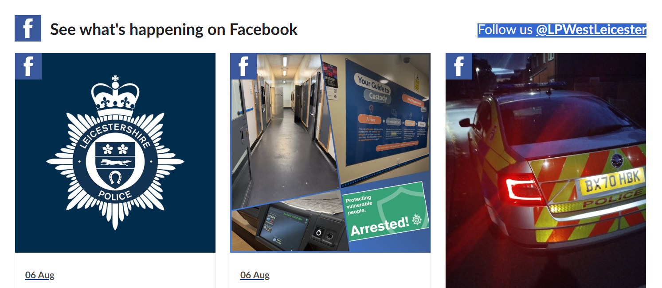
nts November 25

We are more than just a beat team
We are part of Team Leicestershire

Leicester Caribbean Carnival
Lots of our officers were on Leicester Caribbean Carnival, working together with other beat officer to make sure this important event went smoothly and safely for all who attended.
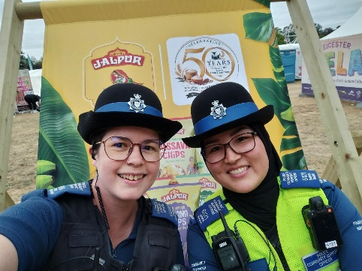
Mela Festival at Abbey Park
PCSO Sabra and Abby attended the Mela Festival at Abbey Park, where they engaged with many members of the community, sampled a variety of delicious foods, and took part in a drumming session.


Lots Of Time in Court
PC 1228 Dave Martin & PC 4374Callum JOHNSTON have spent a lot of time in courts, taking offenders back in relation to breach of conditions, and get civil injunctions threw the courts to address people’s criminal activity on the area.

