Welcome to your Oakham & Barleythorpe police e-newsletter. Here you will find all of the latest news from an Oakham & Barleythorpe policing perspective.
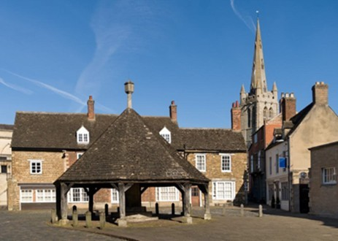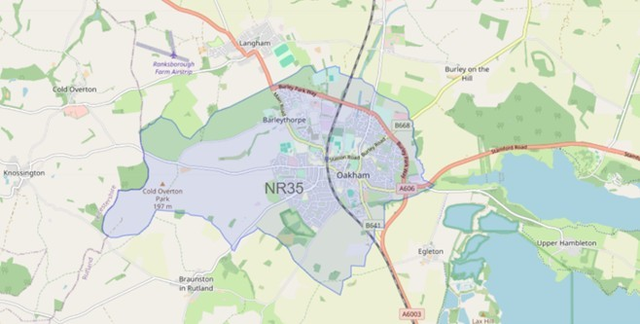

What matters to you

We have listened to you and the concerns you have raised through surveys, community consultations and analysing crime trends.

Oakham & Barleythorpe Newsletter
July 2026
Using this data, we have created the following Oakham & Barleythorpe priorities that the Dedicated Neighbourhood Team will focus their efforts on:

Page 1

Oakham & Barleythorpe Newsletter

Priority 1: Anti-social behaviour (ASB): You said: Anti-social behaviour in and around Oakham & Barleythorpe is becoming more frequent in certain areas.
What we have done: During June, PC Hughes and I worked alongside Community Safety and the Safer Streets Team to tackle ASB in identified hotspot areas. Through joint patrols, engagement with residents and local businesses, and targeted interventions, we have identified several perpetrators, issued advice and warnings where appropriate, and issued a Section 59 warning for the anti-social use of a vehicle.

Priority 2: Road Safety: You said: Speeding vehicles on Oakham & Barleythorpe roads is a priority you want us to address, specifically the lack of adherence to 30mph zones.
What We Have Done: This past month, myself, PC Hughes and response officers have been actively addressing road safety concerns, with a particular focus on speeding. We have carried out targeted speed enforcement in identified hotspot areas, using both mobile speed detection equipment and high-visibility patrols to deter offending drivers. We’ve also engaged with members of the community to raise awareness of the dangers of speeding and encourage safer driving behaviours. Where necessary, appropriate enforcement action has been taken, with the aim of improving road safety, reducing risk, and helping to keep our local roads safe for everyone.

Priority 3: Drug dealing/taking: You said: Reports of drug dealing/ taking in and around Oakham & Barleythorpe.
What We Have Done: Throughout July, the Oakham Team has continued to tackle drug-related offending through targeted patrols, intelligence-led activity, and proactive policing. As a result of this focused work, several suspects have been identified and arrested for drug offences, helping to disrupt criminal activity within the area. Officers have also carried out a number of stop checks at locations of concern, gathering valuable intelligence and supporting ongoing investigations.

This past month we have seen-

5 drug related offences
0 reports of Road Safety 3 report of Anti-Social Behaviour
Anti-social behaviour
PC Hughes and myself have been working closely with local residents and partner agencies to tackle reports of anti-social behaviour in the area. Through increased patrols, community engagement and proactive enforcement, we have identified those responsible and taken positive action to address concerns. As part of this work, Section 59 warnings have been issued to individuals involved in the anti-social use of vehicles. We will continue to monitor the area and encourage residents to report any ongoing issues so that we can keep our communities safe and enjoyable for everyone.

If you’ve witnessed antisocial behaviour, please report it to us. Report antisocial behaviour | Leicestershire Police (leics.police.uk)
Community engagements—come along and meet the team!
25.08.2026, 10:00– Beat surgery at Oakham Castle, a chance to meet your neighbourhood team and report any concerns to the Police.

