
Tackling Anti-Social Behaviour

Get the latest crime statistics
by
v
isiting:

www.kent.police.uk/yourare
a

Beltinge & Reculver

Ward

newsletter

April
202666

.

Here is your monthly update on the work carried out across the wards of Beltinge and Reculver over the past few weeks. Thank you to all residents who continue to report concerns and support our policing efforts. Your information helps us target issues effectively and keep our community safe.

Over the past few weeks, I have been continuing work across the neighbourhood to tackle anti-social behaviour (ASB) and address community concerns.

- Regular foot patrols have been carried out in locations identified as ASB hotspots to provide reassurance and deter further incidents.

- A male well known for persistent anti-social behaviour was arrested for breaching court bail conditions, following continued issues in the area.

- I have engaged with local businesses and establishments after reports of ASB, working closely with them to gather information and prevent repeat incidents.

- CCTV footage was reviewed to help identify individuals involved in reported incidents.
- High-visibility patrols were conducted during key times when ASB was most likely to occur, helping to reduce incidents and support residents and businesses.

Update: ASB, Disturbances & Drug Use at a Residential Flat

Following previous reports and concerns shared in an earlier newsletter regarding ongoing issues at a residential flat, I can provide the following update.
Residents had reported:

- Frequent visitors linked to suspected drug use and aggressive behaviour

- Loud arguments, incoherent shouting, crying, and noise disturbances continuing into the early hours

- Sounds of banging and items being damaged within the property

- Strong smells of cannabis affecting nearby residents and communal areas

Action Taken:

Working jointly with a colleague from the Anti-Social Behaviour Team, we successfully applied for a closure order at Margate Magistrates’ Court.

As a result:

- The property has been closed for three months.

- No one is permitted to enter the flat during this period, except emergency services and social services.

- The order provides additional powers for police to arrest anyone who attempts to access the premises unlawfully while the closure is in place.

- This action has been taken to protect local residents and restore peace within the community.

Road Safety:

Road safety continues to be a key priority within the ward, with particular concern around the illegal and anti-social use of e-scooters and vehicles on public roads.

My colleagues and I have been carrying out targeted patrols to address reports of unsafe driving and riding which pose a risk to pedestrians, cyclists, and other road users.

Action Taken:

During patrols on the Old Thanet Way (A299), my colleagues and I stopped a male who was driving in an anti-social manner. As a result, the driver was issued with a Section 59 Warning.

What is a Section 59 Warning?

A Section 59 comes under the Police Reform Act 2002 and is used when a vehicle is being driven carelessly, inconsiderately, or in a way that causes alarm, distress, or annoyance to members of the public.

- The warning is recorded against both the driver and the vehicle.

- If the same vehicle or driver is involved in further anti-social use within 12 months, police have the power to seize the vehicle.

Section 59 powers are commonly used to tackle issues such as dangerous driving, nuisance vehicle use, and illegal e-scooters on public roads.

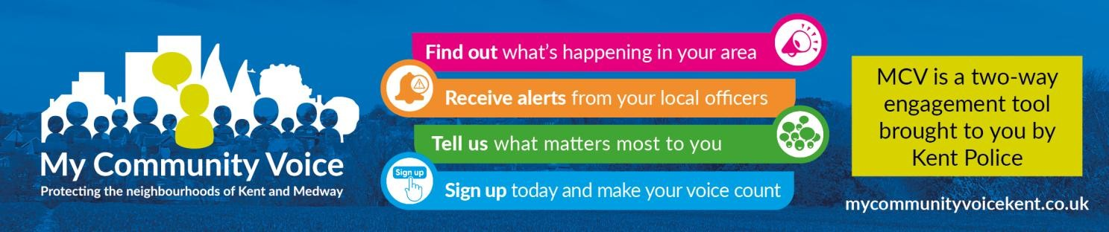
- Supporting our community: By working closely with residents, local partners, and community groups, we aim to build trust, improve safety, and create stronger relationships across the area. Whether it’s providing reassurance, acting on concerns, or helping vulnerable individuals access the support they need, our focus is on being visible, approachable, and proactive. Together, we can continue making our neighbourhood a safer and more positive place to live.

1


Community Engagement: We are committed to engaging with the Coastal Wards community. This includes holding regular community meetings, which are advertised via My Community Voice. We want to hear your concerns and work together to find solutions.

We are committed to keeping you informed. We publish this monthly newsletter and provide updates on local crime trends and the work we are doing to address these issues on My Community Voice.

2

Next month’s engagements:  - Thursday 14th May 2026 10:00 – 11:30 – (Heron Leisure Centre) HatHats Coffee, Herne Bay Central, William Street, Herne Bay, CT6 5NX  - Tuesday 19th May 2026 10:00 -11:300 – HatHats Coffee, Reculver, Ct6 6SS.  - Thursday 28th May 2026 15:30 -17:00 – Costa Coffee, 6 The Boulevard, Herne Bay, CT6 6GZ. | Your local officer:  PC Jack Roy

