
Issue: June Edition 2026
Melton Mowbray Town Centre Newsletter

The NR31 Beat Team
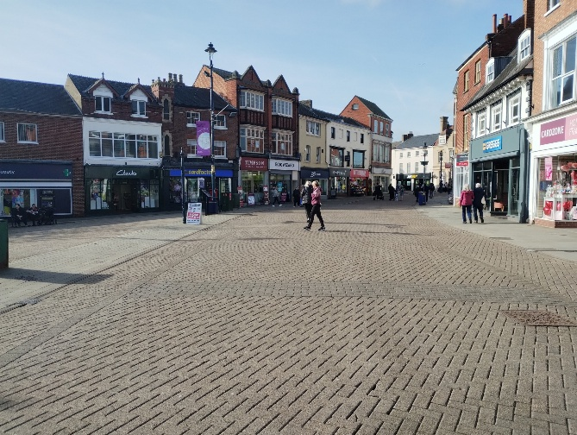

- PC 1836 Lucy Baxter

- PCSO 6193 Fenner Rushby
- CSO 6017 Etienne Kennington-Dawe

What matters to you
We have listened to you and the concerns you raised and prioritized the following:

Priority 1: Antisocial Behavior
The community has raised the issue of Anti-Social Behavior on the Melton Town Beat as a top priority.
What we have done:
We are continuing to work with our partner agencies to stop the ASB throughout the town. For example, conducting patch walks with the local council, having frequent meetings with members of our SMART group to gather information and to find out where our ASB hot spots are located.

Priority 2: Drug Dealing

What we have done: Throughout the month, we have been carrying out intelligence-led work to identify, disrupt and act against those involved in drug-related activity. For example, after a report of a male drug driving, we managed to use intelligence to eventually track the vehicle down and get it seized- meaning one less danger on the roads.

Priority 3: Retail Theft
What we have done: Proactive patrols are being completed in the town centre to deter people from shoplifting. A visible police presence makes a significant difference by reassuring members of the public, increasing opportunities to identify and engage with potential offenders, and acting as a deterrent to criminal behaviour. Officers are also conducting high-visibility patrols, engaging with local businesses, and gathering intelligence to help reduce theft-related offences and maintain a safe environment for residents, visitors, and retailers.

FATAL 4 OP
What We have been up to..

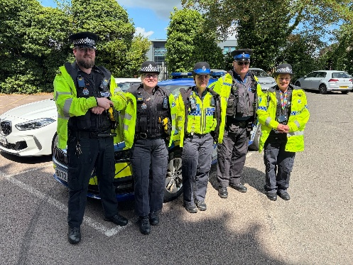
Towards the very beginning of the month PCSO Etienne and PC Lucy joined in with a local FATAL 4 Operation that took place on the town beat. The FATAL 4 focuses on Speeding, Drink and Drug driving, using a mobile phone whilst driving and not wearing a seatbelt. 4 Very dangerous things to be doing behind the wheel. Throughout the Op a total of 12 vehicles were stopped for these offences.

It’s been a very hot month! But that doesn’t stop us, here’s what we’ve been up to…

- PCSO Etienne seized a vehicle reported of driving around with no tax… a reminder to pay your car tax!
- PC Lucy Seized a vehicle reported of drug driving and driving without a licence- a small win, but one more danger off the roads.
- PCSO Fenner attended multiple Road traffic collisions, providing road closures, traffic management and first aid at both.
- Alongside PCSO Malcom, PCSO Etienne made a visit to the sunny skie’s café for a fundraiser event. It was a lovely opportunity to see everyone enjoying themselves in the sunny weather, and to speak to a few members of the public about what we do day to day.
- PC Lucy completed a much-needed patch walk with Katie from the Safer communities Team, to discuss the ASB and rising issues in the town centre.

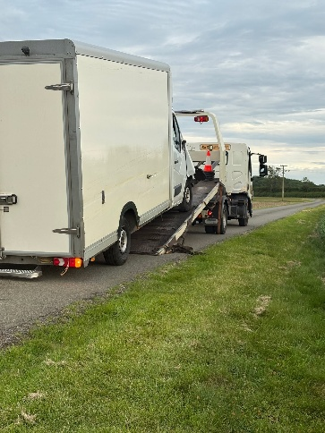
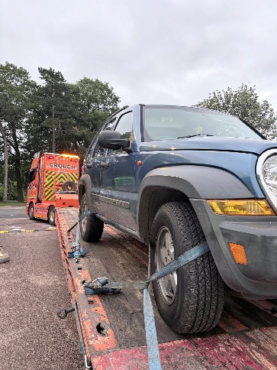
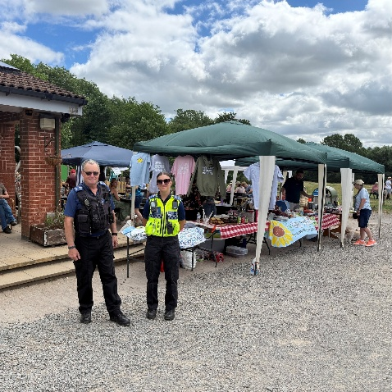

Beat surgeries to attend…

  - Town Park Cafe (04/07/2026 15:00)
  - Beat Surgery at The Library (14/07/2026 10:00)
  - Cattle Market Beat Surgery (14/07/2026 10:00)
  - McDonalds Beat Surgery (31/07/2026 17:00)
  - Esquires Melton Mowbray (03/08/2026 10:00)
  - The Hanger Beat Surgery (14/08/2026 11:00)
  - Melton Town Park Beat Surgery (30/08/2026 14:00)
  - More to be confirmed! Keep an eye out on Neighbourhood link and our Facebook page.
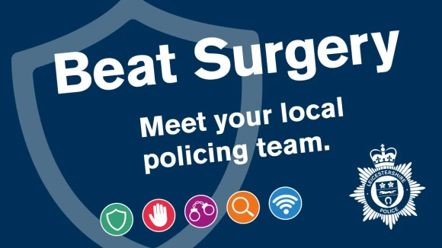
Why should you come down to our beat surgery?
Beat surgeries are regular community engagement events held by the local neighbourhood policing team.

They provide an opportunity for you to speak directly with police officers and PCSOs about issues affecting their area.

Whether it is concerns around antisocial behaviour, crime, road safety, or other community matters, beat surgeries allow you to raise your concerns, share information, and receive crime prevention advice in a relaxed and accessible setting.

These events are an important part of neighbourhood policing, helping officers to better understand local priorities, gather valuable community intelligence, and work with residents to identify solutions to ongoing issues. By maintaining an open dialogue with the public, beat surgeries help strengthen relationships between the police and the community, ensuring that local concerns continue to shape policing activity.

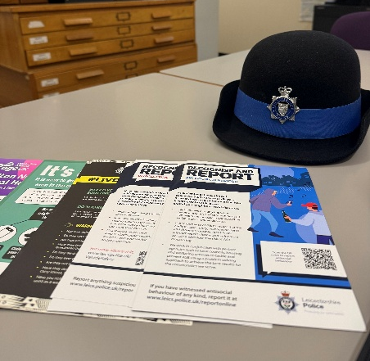

For the future

Please continue to report any suspicious activity to the police on either 101 or on the website.
Thanks for reading the newsletter!

Contact us on:
Melton Police - FACEBOOK
101 – NON EMEGENCIES
999- EMERGENCIES
Melton Station Front Desk.

