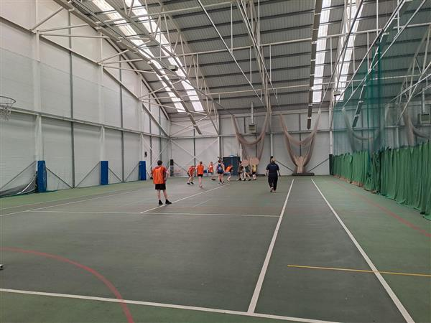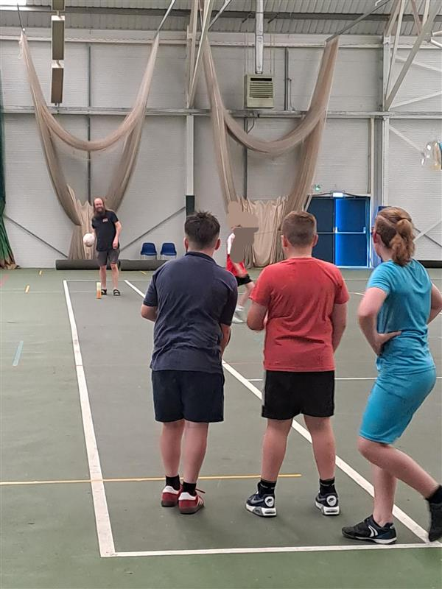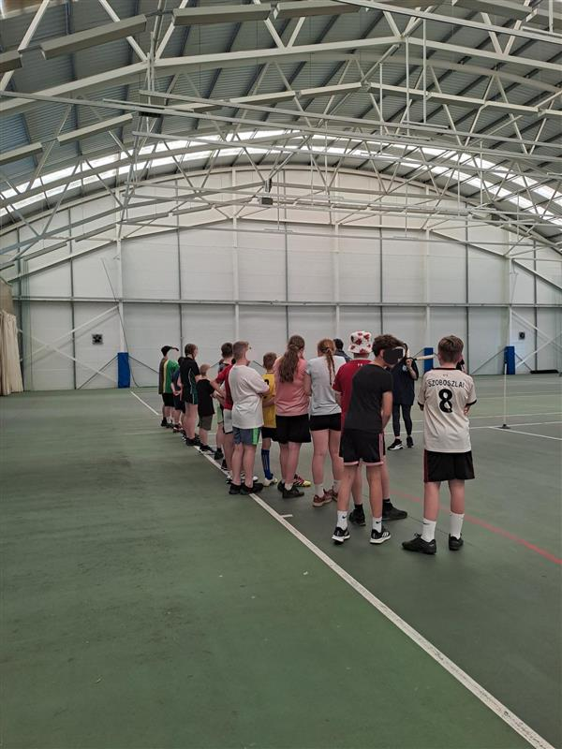
Police Academy Sports Star Event!!
What a brilliant day yesterday we had at our regular half term Police Academy Sports Star Event at Bridge Street Sports centre, even if it was one of the hottest days of the year so far!
We ‘warmed’ up with the bleep test, then played football, netball and finished off with a game of rounders.
A big thank to Morrisons and Radnor Water for supplying the drinks and snack for the event and the PCC for funding the hire of the hall.
We look forward to hosting the next event in the summer holidays……. watch this space for details.
On behalf of Leominster Safer Neighbourhood Team.

We

