STAFFS WATCH
Staffordshire
Neighbourhood Watch Association (NW)

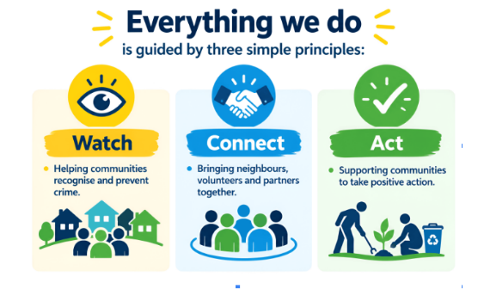
Volunteering with Neighbourhood Watch
There are lots of ways to volunteer and engage with Neighbourhood Watch. This guide is intended to give an overview of each role and direct you to further information about them.
Neighbourhood Watch (NW) is the largest volunteer-led crime prevention charity in the country. Our mission is to support people and communities to be connected, active and safe. Each Policing area or county has an NW Association which supports schemes and members within that area.

Each association comprises of:
Members
Scheme members
Scheme Coordinators
Area Coordinators
Association members
Further information can be found at
www.ourwatch.org.uk
https://ourwatch.myhubintranet.com/
or reply to this message
Members
NW members receive local and national crime prevention advice.
Local updates and information from local police via Smart Alert
Lower insurance premiums from some providers

Scheme Members
As above, and are part of a local scheme, looking out for neighbours, receiving information from the scheme coordinator and being part of their communities. They may be part of, for example, a WhatsApp group to share any concerns and issues they may have.

Scheme Coordinators
Start your own scheme. This can be your own street or include neighbouring streets.
You can then contact your neighbours and invite them to join the scheme.
Act as point of contact with residents and local PCSO’s to receive and cascade information relevant to members such as crime reduction information to encourage members to improve their home, online and personal security.
Signpost members with community safety concerns to local organisations.
Encourage members to report crime to the Police.
Encourage members to keep an eye on each other and their properties, especially the elderly or those that may be vulnerable
Support local Police and other agencies to identify local issues and solve problems
Arrange or attend local events.
Access your online members area to send messages, invite new members and access resources such as the knowledge hub.
How much you do is entirely up to you, depending on how much time you can commit.

Area Coordinators
Support a range of schemes in their area.
Connect with local coordinators and support and connect them together.
Develop relationships with Police and local stakeholders such as the local councils.
Apply for community grants.
Access support and training on the Knowledge Hub.
We currently only have 2 area coordinators
Association roles and responsibilities
Staffordshire is split into 10 Policing areas, Staffordshire Moorlands, Stoke North, Stoke South, Newcastle under Lyme, Stafford, Cannock Chase, Lichfield, Burton on Trent, South Staffs and Tamworth.
The aim of the association is to have a lead in each of these areas. We currently only have 4 areas covered.
The Association also has elected roles of Chairman, Vice Chairman, Secretary and Treasurer.
Responsibilities
Supporting the setup of new schemes.
Ongoing support for existing schemes such as training, resources and events development.
Building and maintaining partnerships with PCC’s (Police and Crime Commissioner), Policing teams, councils and community organisations.
Fundraising
Promoting Neighbourhood Watch
Maintaining accurate records via the online system
Responding to enquiries
Ensure strong visibility e.g social media

