  BHP WARD PANNEL MEETING  24.09.2026 | Meet the team:  Sergeant 691NA KING, Aaron  PC 1469NA MEHMED, Imran  PC 1310NA DELL, Steve  PCSO 7212NA JOHNSON, Girvan


Bush Hill Park ward panel
Panel chair: Glen Breslin
Councillors: James Hockney, Peter Fallart & Pat Gregory
Ward Priorities:
- Motor vehicle crime
- Burglaries
- ASB

Get crime prevention advice at:
www.met.police.uk/crimeprevention
You can report a crime in your area anonymously via CRIMESTOPPERS. They never ask for your personal information and do not track your device. They are an independent charity that gives the people the power to speak up to stop crime 100% anonymously. Call them or fill in their anonymous online form.
To contact police
*If a crime is happening now or someone is in immediate danger, call 999*Find out other ways to contact us on this link:
https://www.met.police.uk/contact-us/
Front Counter - Edmonton Police Station
462 Fore Street, Edmonton N9 0PW
Help to make your neighbourhood safer
Attend meetings organised by us, give us a call or drop us an email. Have your say and work with us to find lasting solutions
Become a volunteer, Special Constable or Police Community Support Officer (PCSO) – For details visit:

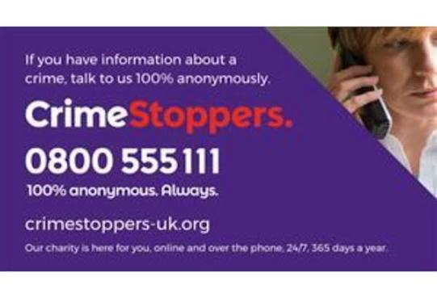

Ward panel news

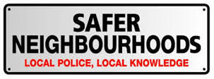


As part of our ongoing efforts to in managing particle crimes which matter to residents within our ward officers will be soon undergoing a speeding OP which will be conducted to deter speeding motorist and putting member of the public at risk. These areas have been previously patrolled in high visibility. Secondly addressing any concerns regarding parking officers have eradicate the issue with Bush Hill parade and are no looking at other area within our ward to deter this from happening.

Examples of Anti-Social Behaviour (ASB) include:
- Excessive noise, such as loud music, shouting, or parties.
- Harassment, intimidation, or threatening behaviour.
- Verbal abuse towards neighbours or members of the public.
- Repeated nuisance behaviour causing alarm or distress.
- Vandalism, graffiti, or criminal damage.
- Fly-tipping or littering.
- Drug-related activity in public places.
- Street drinking causing disorder.
- Groups gathering and causing intimidation or nuisance.
- Dangerous or inconsiderate use of vehicles, including off-road bikes.
- Persistent dog barking or failure to control dogs.
- Public drunkenness leading to disorderly conduct.
- Throwing objects at property or people.
- Misuse of fireworks.
- Begging aggressively or causing harassment.
- Trespassing that causes nuisance or fear.
For police or local authority purposes, ASB is generally behaviour that is likely to cause harassment, alarm, or distress to any person not of the same household, or conduct capable of causing nuisance or annoyance in relation to housing-related matters.

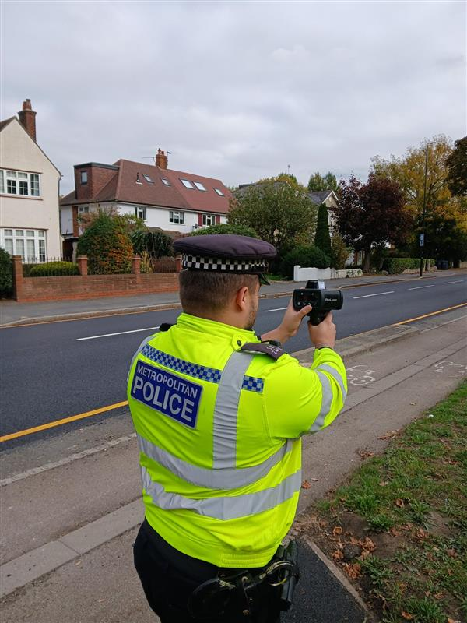
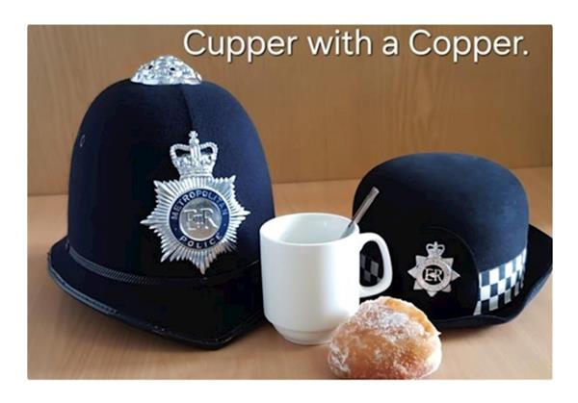
Community engagements

#
It has come to officers’ attention that we have to bring across more community engagement which means more community contact points meeting as well as cuppa with a Coppa to address any on going situation or for a general conversation with officers, for this alone we can receive feedback and members of the public can see the action being taken place within their ward.

Ward priorities from of 24/09/2026
- Burglaries- specifically Village Road, Park Avenue, Faversham, Queen Anne’s Grove, Firs lane
- Motor vehicle crime- Taking notes of recent trends and vehicle taken via theft
- Drugs-Hyde Park Avenue, Solna Road, Sawsbury Way
Actions of priorities
An Op is going to take place to clamp down on speeding within Bush Hill Park and the hotspots to deter drivers from speeding and keep road users as well as public safe.
Motor vehicle crime is going to be monitored with high-visibility patrols, look out for us we’ll stand out
Drug use has been something that officers are aware of and have given out community resolutions and have no issue giving out more. Please if this matter is bothering you please let us know as we can be everywhere but give us the time and the place and you will be sure to see us.

BHP ward figures for the month September
- ABH – 1 GBH – 0
- Burglary business / com – 1
- Residential burglary home – 5
- Attempted burglary residential – 1
- Theft of motor vehicle – 4
- Theft from motor vehicle – 5
- Criminal damage – 1

Stats over the month

